30) Develop wireframes for a visually rich mobile app with optimized graphics and UI performance, using Figma to showcase the design principles.

Aim:
To Develop wireframes for a visually rich mobile app with optimized graphics and UI performance, using Figma to showcase the design principles.

Procedure:
- Open Figma
- Create a new file
- Select the Frames
- Design Visual Elements
- Make it Interactive
- Add icons on the Frame
- Incorporate Multimedia
- Storyboard Animation
- Review and edit the Prototype
- Save and Share
Design:
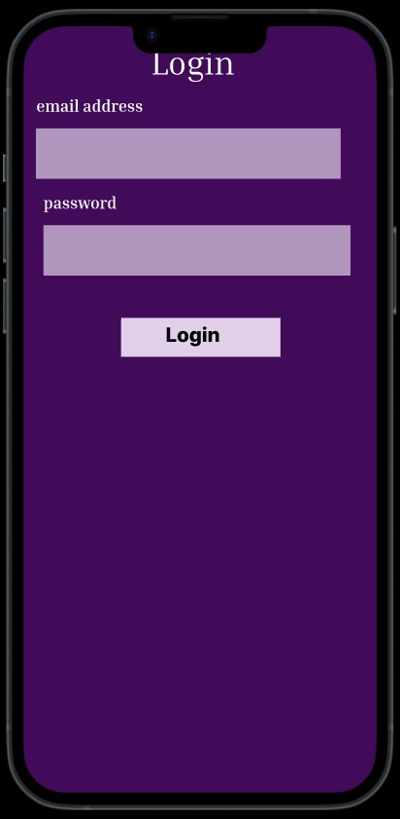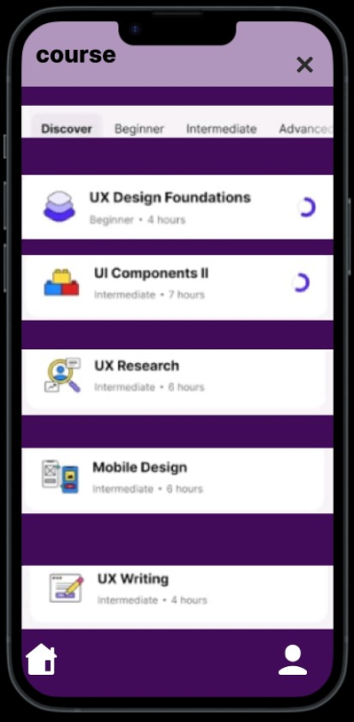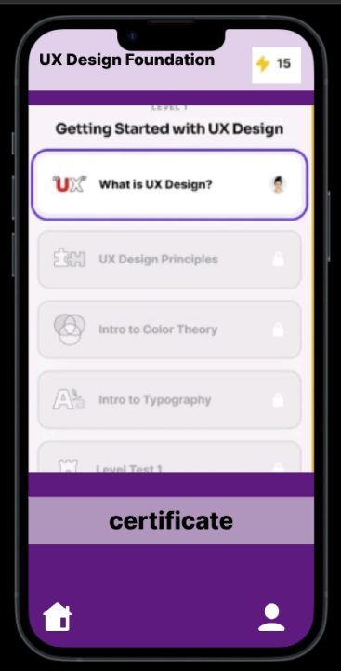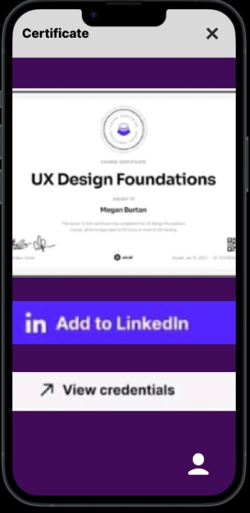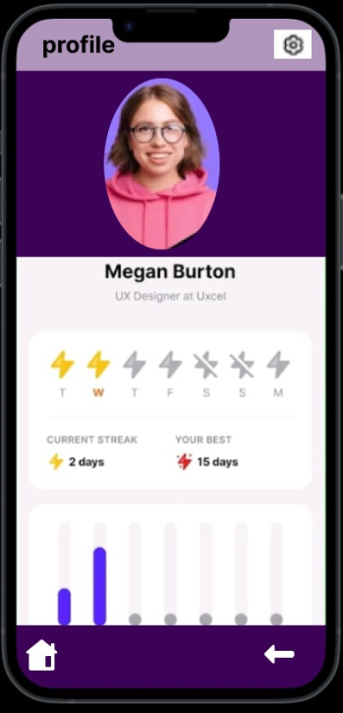
Prototype:
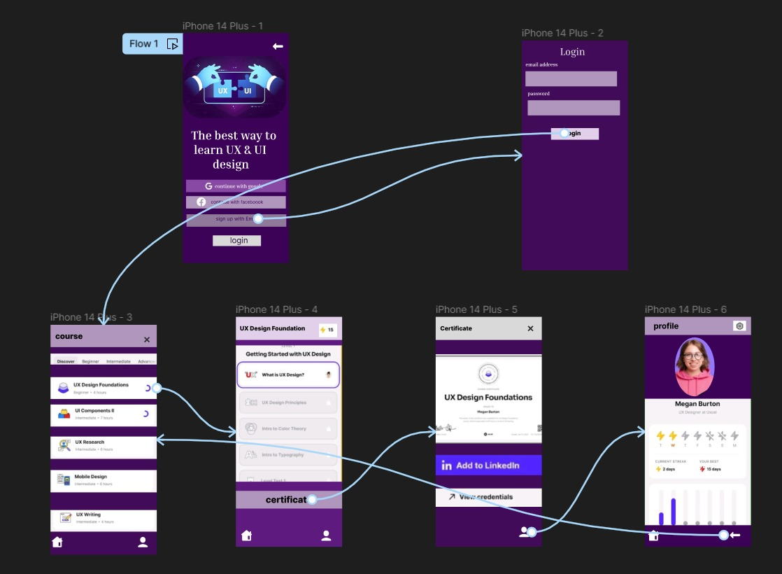

Result:
Thus The Develop wireframes for a visually rich mobile app with optimized graphics and UI performance is created and executed successfully.

